FOR IMMEDIATE RELEASE: PRESS CONTACT:
Meredith Barnes | Senior Publicity Manager
mbarnes@sohopress.com | (212) 260-1900
Enter Pale death
A Joe Sandilands Investigation
by Barbara Cleverly

Sandilands’s investigation of a “death by misadventure” forces him to confront the sordid lives of the rich, an ancient equine brotherhood, and his own fiancée’s dark secrets.
With a title inspired by the Biblical apocalyptic riders, the seventh installment in the Joe Sandilands series, ENTER PALE DEATH (Soho Crime, December 2014), promises and delivers a sinister murder mystery set during the tumultuous years between one Great War and the next.
This time Joe Sandilands, Assistant Commissioner of Scotland Yard, is staying out of international politics. Instead, he finds himself wrapped up in the mannerly intrigue of the Trueloves, a filthy rich family whose eldest son has just lost his eccentric young wife. True, the horse she tried to tame, alone, at the crack of dawn, was notorious for being unrideable. But the savageness of the woman’s death is shocking nonetheless.
Sandilands is never one to turn down a challenging case, but this time there is another motivation: Sandilands’s fiancée is a budding scientist, studying under none other than Mr. James Truelove, the widower. And rumor has it that Mrs. Truelove tried to tame the untameable horse in part to prove her superiority to the young student who seems, to Sandilands’s dismay, to have caught James’s eye for more than her intellect.
Sandilands travels to the small town surrounding the Truelove estate and begins working the case with the local Chief of Police. They encounter strange green men stalking the forest, crooked local cops with enigmatic agendas, and a millennia-old brotherhood of horsemen who may hold the key to Mrs. Truelove’s baffling death.
With ENTER PALE DEATH, the CWA Dagger-winning Cleverly delivers yet another of her meticulously researched, immensely satisfying historical mysteries, which have been praised as “spellbinding” by The New York Times, “darkly glamorous” by Kirkus and “addictive” by the Historical Novels Review.

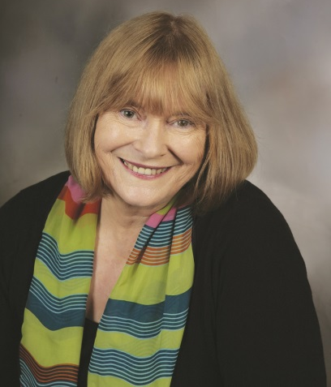
About the Author
Barbara Cleverly was born in the north of England and is a graduate of Durham University. A former teacher, she has spent her working life in Cambridgeshire and Suffolk; she now lives in Cambridge. She has one son and five step-children. She is the author of nine books, including The Last Kashmiri Rose, Strange Images of Death, The Blood Royal, and Not My Blood. Her Joe Sandilands series, set against the background of the Indian Empire, was inspired by the contents of a battered old tin trunk that she found in her attic.

Soho Crime • Hardcover • Pub Date: December 2, 2014 • Price: $26.95 ISBN: 9781616954086 • eISBN: 9781616954093 Agent: Juliet Burton
Praise for the
Joe Sandilands investigations:

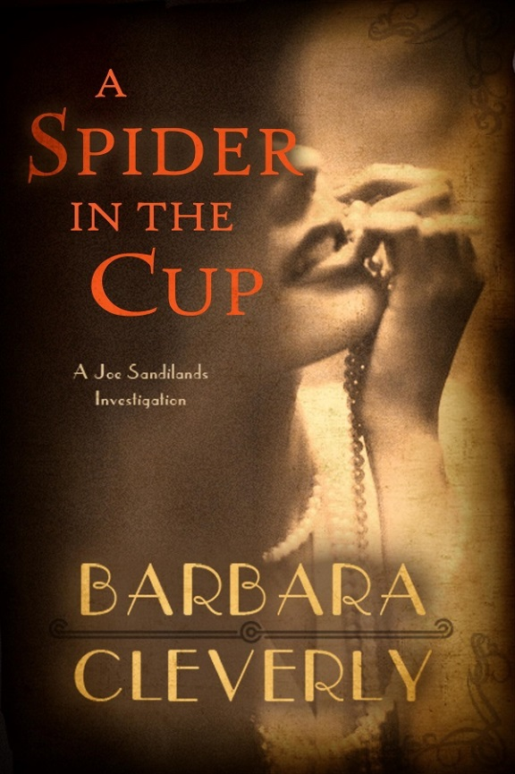
“[A] suspenseful and intricate tale of honor and betrayal.”
—Suspense Magazine

“Secret societies, economic and political power plays, and assassins on the loose share space in…[an] involving tale, marked by historical, cultural, and literary references, stiff-upper-lip dialogue, and occasionally surprising wittiness.”
—Booklist

“Spectacular and dashing. Spellbinding.”
—New York Times Book Review
“Cleverly's crisp prose and solid cast of supporting characters...make the book a delight to read.”
—Denver Post
"Barbara Cleverly lives up to her surname with her intricate, erudite and witty books about Scotland Yard detective Joe Sandilands....Cleverly is a terrific plotter, and her prose highlights a keen sense of place, character and dialogue....Fans of P.D. James, take note: Here's a worthy colleague."
—Seattle Times
“Stylish and intricate....Cleverly has perfect pitch for period and place, whether her hero is unearthing evil in India, England or France.”
HC 8/20/2013 │ PBK 7/8/14
—Richmond Times-Dispatch
“A great blood and guts blockbuster.”
—The Guardian

“Cleverly neatly captures the style and feeling of the period between the world wars and provides plenty of mystery, suspense and danger.”
—Kirkus

“Cleverly is a terrific writer, and she’s also wonderful at setting a scene. Fans know that she supplies the glamour as well as the grime, and she’s one of the most adept puzzle-plot-makers….The clues are all there. But you won’t guess who it is until she gives you the final word.”
—The Globe and Mail

“Cleverly underscores the idea that the actions of great nations can be substantially less noble than the nations themselves; it is a fine writer who can make her readers reflect on such concepts....With each chapter, the reader is drawn further into the narrative and the darkness of the time.”
—The Strand Magazine

