Oct 2014 │ YA Contemporary Psychological Suspense; WWII

In Escape Theory, Margaux Froley introduced Devon Mackintosh’s first turn as Keaton School’s peer counselor. Devon thought it would be a standard college-application-padding ploy (she desperately wants to end up in Stanford’s psych program), but when Keaton’s golden boy, Hutch, seemingly commits suicide, things get intense—and dangerous—fast.

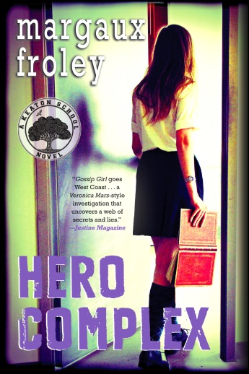
That nightmare has only just ended as HERO COMPLEX opens, and now her own life has been threatened. Solving Hutch’s case only unearthed more questions: What secret lies beneath the Keaton land? What could be so valuable as to tear the Hutchins family apart?

Then Hutch’s grandfather, Reed Hutchins, entrusts Devon with a mysterious diary—days before he dies. With the help of Bodhi and Raven Elliot, Reed’s sole heirs, Devon plunges into Reed’s life as a teenage science prodigy in the immediate aftermath of Pearl Harbor and fights to piece together the final clues to what haunts Keaton: the truth Reed’s enemies are still willing to kill for.

Best regards,
Meredith Barnes • Senior Publicity Manager
mbarnes@sohopress.com • (212) 260-1900

Praise for ESCAPE THEORY

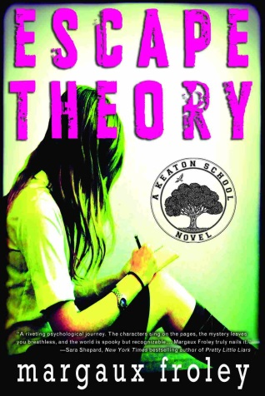
“Escape Theory is a riveting psychological journey—Margaux Froley truly nails it. The characters sing on the pages, the mystery leaves you breathless, and the world is spooky but recognizable... I can't wait for the next Keaton School installment!”
—Sara Shepard New York Times bestselling author of Pretty Little Liars

“A sexy, smart, page turner, a must read!” —Octavia Spencer, Academy Award winning star of The Help

“Escape Theory kept me up way past curfew, with no regrets.” —Cecily von Ziegesar, Gossip Girl

“Gossip Girl goes West Coast ... [Devon] opens a Veronica Mars-style investigation that uncovers a web of secrets and lies.”
—Justine Magazine
“A stellar debut.... With a heady mix of mystery and emotional turmoil, Froley gives readers compelling character development.”
—Publishers Weekly, STARRED REVIEW

“Veronica Mars meets Nancy Drew... This fast-paced novel weaves emotionally rich characters into a complex web of unspoken rules and painful secrets, including love, betrayal, and a deeply entrenched system of pharmaceutical abuse among Keaton's students.”
—School Library Journal

“Froley infuses this story with layered and interesting characters that keep the reader guessing [about].... the super-rich, complicated student body of Keaton School. If this debut novel is any indication of the quality of those to succeed it, the series should have a great following.”
—VOYA
Hero Complex • Soho Teen • Hardcover • 5.5 x 8.25 • October 2014
$17.99 • 280 pages • ISBN: 9781616953201

