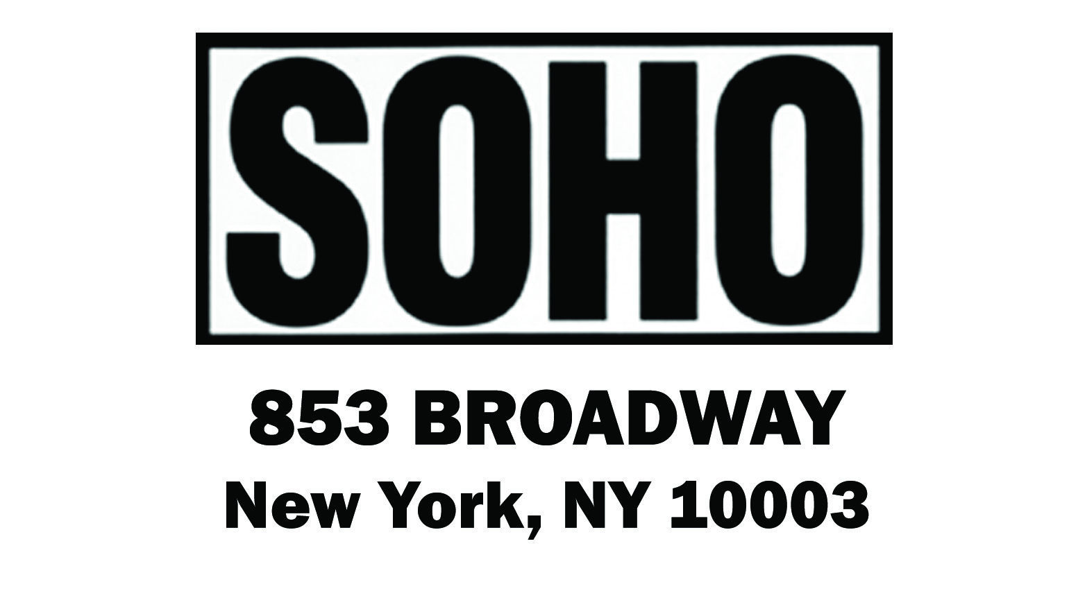
FOR IMMEDIATE RELEASE:
CONTACT: Paul Oliver
Director of Marketing & Publicity
poliver@sohopress.com
(212) 260-1900

SOHO CRIME PRIORITY TITLE
INNOCENCE;
OR, MURDER ON STEEP STREET
Heda Margolius Kovály
Author of Under a Cruel Star

Translated from the Czech by Alex Zucker, PEN Translation Co-Chair
~
"A luminous testament from a dark time, Innocence is at once a clever hommage to Raymond Chandler, and a portrait of a city—Prague—caught and held fast in a state of Kafkaesque paranoia.
Only a great survivor could have written such a book."
—John Banville

Soho Crime • Hardcover/eBook • PUB DATE: June 2nd, 2015 • PRICE: $25.95
Page Count: 272 • ISBN: 9781616954963 • eISBN: 9781616954970

A literary event reminiscent of the publication of Hans Fallada’s Everyman Dies Alone and Irène Némirovsky’s Suite française: Famed Holocaust memoirist Heda Margolius Kovály’s lone novel, nearly lost to censorship and untranslated for decades, knits her own terrifying experiences in Soviet Prague into a powerful work of literary suspense.

Published by the author while living in exile from her native Czechoslovakia, Innocence: Or, Murder on Steep Street (Soho Crime | June, 2015), fascinates as much for its path to publication as it does for its riveting story.

Heda Margolius Kovály is best known for her landmark memoir, Under a Cruel Star, which documents both her struggle to survive first Auschwitz and then Stalinist Czechoslovakia. Her husband, who had survived the horrors of Dachau, had been a part of the Jewish intelligentsia that established communism in Czechoslovakia, only to later be detained and murdered after the now infamous Slanksy show trial put on by the government he had helped create. Branded the wife of a “political traitor,” Heda eked out a living with her son under the Soviet regime. That atmosphere of oppression is what Heda wanted to take aim at in what would be her only novel.

During this time of political exile Kovály worked as much as a translator as memoirist, rendering into Czech the works of Philip Roth, Muriel Spark, and Raymond Chandler, among others. But it was the latter’s work that inspired Heda to turn her pen to fiction. Inspired by Chandler, Kovály knit her own terrifying experiences in early 1950s Communist Prague—her husband's imprisonment and wrongful execution, her own persecution at his disgrace—into a gorgeous psychological thriller-cum-detective novel.
Set in and around a cinema where a murder was recently committed, Innocence follows the unfolding of the investigation while telling the stories of the women who work there as ushers, each of whom is forced to support herself in difficult circumstances. As the novel brings this group alive, it tells their various life stories that have brought them to this job, the secrets they share with one another, and the secrets they keep. When the detective trying to solve the first murder is found slain by the cinema, all of their secrets come into the light. (about the book continued on back)
Innocence was published in 1985 by a Czech-language German expatriate press while Heda was living in exile in London and Boston. It was a single-run limited edition printing, never intended for sale or distribution in Czechoslovakia itself, where Kovály feared it might have adverse effects on her friends and associates because of its critical content. In fact, to further protect anyone who still knew her, Kovály published the book under a pseudonym—Helen Novakova, the same name as her autobiographically-inspired main character. Only in 2013 has the book finally been published in the Czech Republic.

It is with great pride that Soho brings to life this remarkable story, which deftly combines the cultural and political observations of crime fiction with the more emotionally powerful biographical elements of an author that lived through the 20th century’s most brutal times and survived to tell the tale with great humor, wit, and in the case of Innocence, cunning.
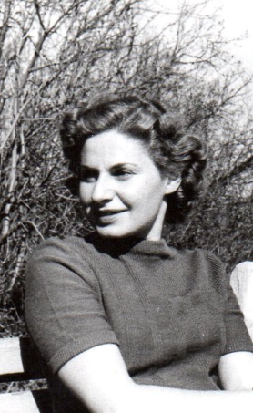
ABOUT THE AUTHOR
Heda Margolius Kovály, a Czech writer and translator, was born in 1919 in Prague to Jewish parents. In 1944 she and her family were taken to Auschwitz. Her parents were immediately killed, but Heda managed to survive by getting selected for a work detail. After escaping from a transport to Bergen-Belsen, she was reunited with her husband, who had survived Dachau and become a devout Communist. In 1952, he would be tried for conspiracy and killed in a Czech jail.
Under a Cruel Star, Kovály's memoir of her time in Auschwitz and the early years of Czechoslovak communism, was first published in 1973. It has since been published in many languages all over the world. Her crime novel, Innocence, is based in large part on her own experiences in early 1950s Prague. Kovály died in 2010 at age 91.
“This is an extraordinary memoir, so heartbreaking that I have reread it for months, unable to rise to the business of ‘reviewing’ less a book than a life repeatedly outraged by the worst totalitarians in Europe. Yet it is written with so much quiet respect for the minutiae of justice and truth that one does not know where and how to specify Heda Kovály’s splendidness as a human being.”
—Alfred Kazin, The New York Times Book Review writing about Under a Cruel Star
ABOUT THE TRANSLATOR
Alex Zucker has translated novels by Czech authors Jáchym Topol, Miloslava Holubová, Petra Hůlová, and Patrik Ouředník. Honors he has received include an English PEN Award for Writing in Translation, an NEA Literary Fellowship, and the ALTA National Translation Award. In 2014 he did new subtitles for the digitally restored version of Closely Watched Trains, the 1966 Czechoslovak New Wave classic based on the Bohumil Hrabal novella. Alex lives in the Greenpoint neighborhood of Brooklyn, New York. Visit his website at www.alexjzucker.com
PRAISE FOR INNOCENCE; OR, MURDER ON STEEP STREET
"Capturing the fear and oppression of living in a police state, this dark novel, reflective of its time and written by a writer who lived her material, will enthrall noir enthusiasts and readers of literary historical fiction."—Library Journal
"In noirish tones, [Innocence] depicts the dark streets, the lost souls, and a very difficult time to be judged guilty or innocent by one’s supposed friends or by the oppressive and rising Czechoslovakian Communist regime."—Booklist
"Previously unpublished in English, this mystery by the late Czech translator and author of the memoir Under a Cruel Star vividly depicts Communist-oppressed 1950s Prague... That Kovaly's first husband was unjustly executed by the Czechoslovak Communist Party in 1952 gives her narrative of double lives and betrayal a painful veracity."—Publishers Weekly
“Double lives, secrets, informers, microdots, and above all, lies . . . Set in post-war Prague, a repressive political maze, Innocence is a must-read, a psychological drama played out in crystal prose. Not only did Heda Margolius Kovály write an emotionally wrenching tale, she lived it during the 1950s Communist state.”—Cara Black
"Kovály’s skill as a mystery writer shines, as she uses suspense, hints, and suggestions to literally play with the reader’s mind . . . An excellent novel."—New York Journal of Books

