FOR IMMEDIATE RELEASE:
CONTACT: Paul Oliver
Director of Marketing & Publicity
poliver@sohopress.com
(212) 260-1900

SOHO PRESS PRIORITY TITLE—DEBUT NOVEL
BURNING DOWN
GEORGE ORWELL’S HOUSE
Andrew Ervin
"Burning Down George Orwell's House is really most enjoyable, a witty, original turn on the life and memory of the Sage of Jura, taking place on the island where he wrote Nineteen Eighty-Four. Eric Blair serves as the McGuffin in this story, which is one part black comedy and one part a meditation on modern life. It is well-written and truly original."
—Robert Stone
Soho Press • Hardcover/eBook • PUB DATE: May 5th, 2015 • PRICE: $25.95
Page Count: 288 • ISBN: 9781616954949 • eISBN: 9781616954956

Set partly in Chicago and mostly on the remote Scottish Isle of Jura, Andrew Ervin’s debut novel is a darkly comic tale of advertising, truth, single malt whisky, Scottish hospitality—or lack thereof—and George Orwell's Nineteen Eighty-Four. There’s also a werewolf. Maybe.

In Andrew Ervin’s Burning Down George Orwell’s House (Soho Press | May, 2015) Ray Welter is a man adrift, desperate to find some sort of personal mooring. A decade of work as an advertising executive in Chicago has left him with shiftless nights and a complete lack of self-respect. Ray may be the architect behind one of his firm’s greatest successes—a campaign advertising gas guzzling SUVs—but he is also no longer comfortable with the man in the mirror.

With the inevitable divorce from his wife looming, and his next work project the heinous task of improving public perception about the fracking industry, Ray decides it’s time for a change. A love of single malt Scotch whisky and a lifelong fixation on George Orwell’s Nineteen Eighty-Four leads Ray to a strange and extreme decision. He will leave his former life behind and spend every last cent of his savings on a six-month rental of Orwell’s Barnhill Estate on the extremely remote Isle of Jura, Scotland. He will immerse himself in the world of his hero and cleanse his soul with bottle after bottle of the local stuff.

Such a simple plan warrants the most complex undoing. Hostile locals (one of them a psychotic certain that Ray is after his daughter’s feminine wiles), food he doesn’t like and can barely digest, chaotic weather, the treacherous Corryvreckan whirlpool, and the rumor of a werewolf all conspire to undue Ray’s quest for self. What’s more, in the dark, when he’s alone, Ray Welter quickly realizes that the potential werewolf is the least of his concerns.

Andrew Ervin has created a rakish everyman hero whose quest to find himself (and the perfect tipple) is nearly as noble as his hangovers are painful. And for that you’ll be thankful for this wise, fun, and above all big-hearted read.
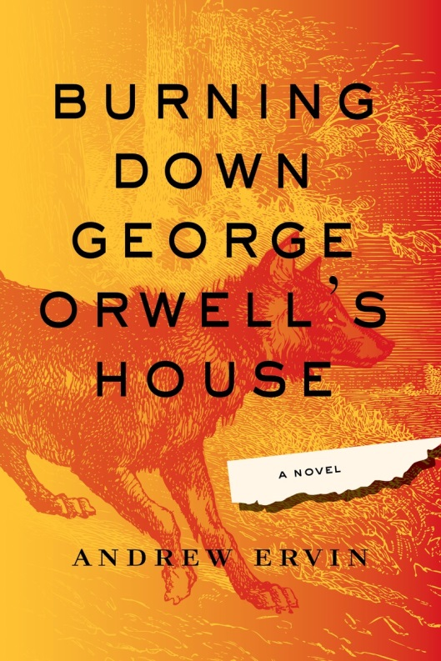
EARLY PRAISE FOR
BURNING DOWN GEORGE ORWELL’S HOUSE

“Burning Down George Orwell’s House is fiction as high-wire act, and Ray Welter is a nowhere man for the ages, going down and out in the shadow of the man himself. Ervin tosses up hilarity and horror, musicality and menace, with page after page of firecracker prose.”
—Marlon James, author of A Brief History of Seven Killings

“Burning Down George Orwell’s House is a wickedly funny novel soaked in wit and whisky as well as a poetic revelation on consumer living. Ervin ingeniously draws you into the disturbing world of Jura and its menacing inhabitants. I loved it.”
—Lisa O’Donnell, author of The Death of Bees

“Ray Welter—corrupted, debauched, cuckolded, fighting all the way down—is a brilliant creation, and Andrew Ervin’s Burning Down George Orwell’s House is a work of laudable mischief.”
—Owen King, author of Double Feature

“Beyond being a vastly entertaining novel, cunningly observed and delicately flavored with the very finest Scotch whisky on the planet, Burning Down George Orwell’s House is a serious meditation on just how Orwellian our world has really become. Let Andrew Ervin help you imagine your way to a world beyond Big Brother.”
—Madison Smartt Bell, author of All Souls’ Rising

ABOUT THE AUTHOR

Andrew Ervin grew up in the Philadelphia suburbs and has lived in Budapest, Illinois, and Louisiana. He has a degree in philosophy and religion from Goucher College and completed his MFA in fiction at the University of Illinois at Urbana-Champaign. His criticism regularly appears in The New York Times Book Review, the Miami Herald, the Philadelphia Inquirer, and elsewhere. He currently lives in Philadelphia with his wife, flutist Elivi Varga. He is the author of Extraordinary Renditions. Burning Down George Orwell's House is his first novel.

